Title: Portrait of Michiel de Ruyter in the Rijksmuseum collection: traces from Rombout Verhulst
Author: dr. ir. Dzemila Sero
Short bio about the author: Dzemila Sero is Migelien Gerritzen Fellow at Rijksmuseum. Her research focuses on artist characterization from traces found on terracotta sculptures, such as epidermal ridge impressions and tool marks. In particular, she uses different imaging techniques to acquire 3D images of these traces and develop image processing software. Her BSc and MSc are in Biomedical Engineering (Politecnico di Milano, Italy), and she holds a PhD in Engineering Science at KU Leuven (Belgium), followed by a postdoctoral training funded by the Impact4Art project (NICAS and NWO) in the Computational Imaging group at the Centrum Wiskunde & Informatica, the national research institute for mathematics and computer science in the Netherlands. Link to her research: https://www.rijksmuseum.nl/en/research/our-research/fellows/imaging-patterns-on-terracotta-sculptures
Text:
Sometimes we may spend a long time searching for a solution, an answer, or a hint, without successfully finding it; other times, it appears as if by magic.
Since 2019, I have been investigating traces, such as epidermal ridge impressions and tool marks, left by artists on their terracotta artworks which are now housed at the Rijksmuseum (Amsterdam). Within the Impact4Art project, I worked in the Computational Imaging group at Centrum Wiskunde & Informatica (CWI, Amsterdam), the national research institute for mathematics and computer science in the Netherlands. Here, I was responsible for establishing a new research line to investigate traces left on terracotta sculptures. The mission was to use the 3D Microscopic Computed Tomography located in the FleX-ray Lab (CWI) and develop new computational imaging methods. The FleX-ray Lab (CWI) is an excellent research facility which aims at allowing scientists to conduct experiments in the fields of mathematics and computer science in a flexible and accessible mode; the lab is pioneer in many research areas of computer science based on CT image acquisitions.
Most of the imaging setups in museum workshops and studios are used to investigate the conservation condition and to monitor the restoration treatments, as well as to allow the public to have access to the museum artworks. Some of the most used technologies to study the surface of artworks are laser and structured light scanning scanners, photogrammetry, whereas 3D computed tomography (CT) and Magnetic Resonance Imaging (MRI) are employed for full volume inspection. Usually, CT and MRI machines are hosted in hospitals, university labs, and research institutes which are equipped with enough space and expertise to house these stations and establish collaborations with museums.
“Terracotta” is an Italian word that literally means ‘baked clay’. Fresh and wet clay is adhesive and sufficiently plastic, it captures everything that has touched its surface, such as dust particles and mineral grains, or that has been pressed or smeared against its surface, like strokes or marks left by a brush, a chisel, and even hands of the maker. Each impression is the negative of the original impression and deformed by pressure; as such, every mark we see is distorted and, to some extent, even degraded. When fired, a process where the artwork is exposed to high temperatures for long hours, clay becomes chemically stable and hard. Under the right conditions, marks left on the object, both on the surface as well as on internal voids, can be kept for centuries, even millennia, allowing us to examine the negative impressions of our predecessors' fingers and palms. At the same time, artworks made of terracotta are fragile and, if not handled with the upmost care, break easily. It should be mentioned that there are other transfer media which can capture marks, including organic substances, photographic film, paint, wax, corroded materials that include copper content; however, skin impressions are less frequently recorded on these materials.
Depending on the quality and quantity of capillary lines, experts estimate whether epidermal ridge impressions belong to fingerprints or to hand palms; feet soles and toes have friction ridges too but, for obvious reasons, they are neglected from the pool of potential marks left on artworks. Because terracotta artworks and other fired clay artifacts, such as roof tiles, bricks, figurines, and utilitarian pots, were molded with tools and bare hands, epidermal ridge impressions are often seen on their surface. For a long time, however, fingerprints have been neglected in research; experts might have noted them, occasionally reported on records, but most of the times, these traces were ignored for further investigation. Only recently, in archaeological research, have scholars begun to use fingerprints to establish the age and sex of past producers; for example, it has been shown that children worked alongside adults both in the Mediterranean Bronze Age and in Scandinavia during the Viking Age. Moreover, the position of fingerprints on artifacts allows us to know exactly how the objects were manufactured.
Each fingerprint is unique and its patterns are dissimilar even to those of fingerprints on one’s own hands. Given the uniqueness of each fingerprint, can we then determine who the sculptor was when we find fingerprints impressed on a surface? The answer is not that simple. First, we may find many epidermal ridge impressions which not necessarily come from fingerprints; in fact, only after careful examination of the capillary lines, expert classify a mark into a fingerprint or a palm print. Second, ridge impressions found on terracotta are often incomplete, which might be the result of scratching the surface with another substance, or it could be the only portion of the finger utilized during modeling. In many instances, only a few capillary lines are visible, making it challenging to declare if these belong to a certain fingerprint. Even if two partial impressions display some degrees of similarity, their incompleteness may not lead to a positive match, as these two may be similar tiny portions from two different impressions. Obviously, even when two partial impressions do not match, one cannot rule out whether they do not belong to the same fingerprint, as they may simply be two different regions of the same fingerprint. To evaluate whether an imprint belongs to an artist, the best case study would be to compare it to all ten of the artist's complete fingerprints. Unfortunately, there is no such database of an artist's fingerprints.
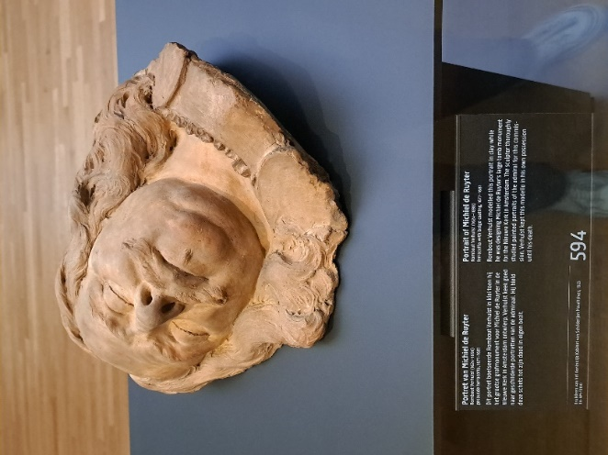
When I first visited room 2.15 at Rijksmuseum, next to the Gallery of Honor, I was in search of interesting marks on terracotta artworks to present at the Speed Date event, which is an occasion for Friends to meet experts working in the museum. Curators, restorers, fellows, and researchers can volunteer to give short presentations about an artwork of preference, not necessarily of their area of expertise. Next to the room’s entrance, it was impossible not to be captured by two imperial looks, modeled by Rombout Verhulst: the portraits of Michiel de Ruyter and Baron Willem Joseph van Ghent.
Terracotta portrait of Michiel de Ruyter (1607-1676), made by Rombout Verhulst (1624-1698). ®Dzemila Sero.
While creating Michiel de Ruyter's massive grave monument for the Nieuwe Kerk in Amsterdam, Rombout Verhulst created this portrait in clay, which is now on long-term loan to the Rijksmuseum (inv. no. BK-NM-13150) from the Koninklijk Kabinet van Schilderijen Mauritshuis in Den Haag. For this assignment, the sculptor meticulously examined painting portraits of the admiral, he has studied the admiral’s features and expressions down to the smallest detail to ensure that in the future we wonder about admiral’s life and courage. Verhulst kept this model in his hands until the day he died. We can almost see the sculptor bent over the commander’s head as he molds his gaze: what was Rombout Verhulst thinking at that moment? Was he satisfied with his work? Was he trying to capture a specific facial expression? How did he do it? These questions continued to echo in my mind.
The portrait of the commander shows the expression of a character impossible to subdue. The commander’s head is framed by flowing and long hair that bears the signs of teethed chisels. Even though this is a sketch model, the artist defined details on the pleated collar and the mole on commander’s cheek.
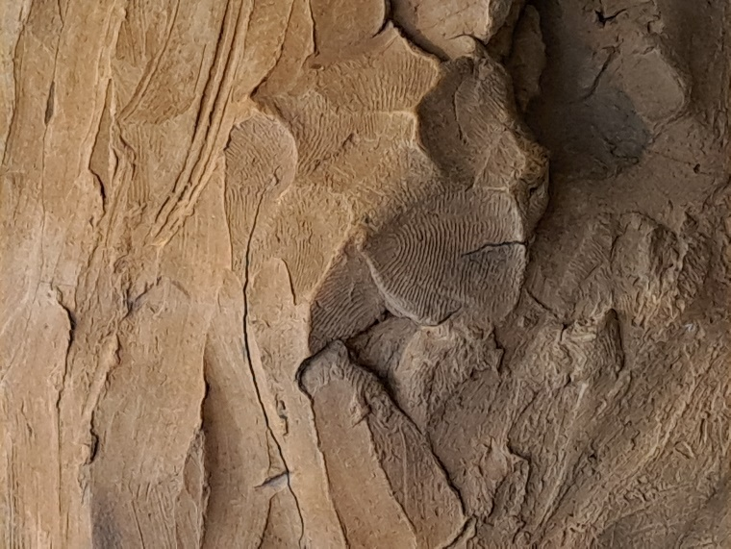
Curiosity has had led me to circle around the sculpture at different viewpoints, over and over again. What I was looking for were traces left by the artist, those unique marks each of us is born with and that stay unchanged forever. These marks are almost imperceptible on a terracotta sculpture if we look from afar. The commander’s mouth, eye sockets, nose cheeks, and even his moustache hair are smooth, polished, free from imperfections. “I’m too optimistic here” I sighed, and suddenly that conclusion seemed amusing. I turned around the protective glass, and I couldn’t suppress a contented smile: to more patient observers, Verhulst left a moving treasure.
(Left) Epidermal ridge impressions found on the surface of the terracotta sculpture “Portrait of Michiel de Ruyter”, made in terracotta by Rombout Verhulst. ®Dzemila Sero.
On the backside, in the middle of admiral’s curly hair, there is a group of clearly visible ridge impressions. Was Verhulst absentminded when he left these marks? Had he secretly in mind to leave them for future generation to see? Among the group of partial capillary lines, a more complete epidermal ridge impression occurs, interrupted by a deep crack; its core might suggest a loop, and several tiny details, known as minutiae, such as ridge endings and bifurcations, are visible as well.
(Right) Re-orientation and magnification of an epidermal ridge impressions found on the sculpture “Portrait of Michiel de Ruyter”. ®Dzemila Sero.
We may not know yet to which fingertip or palm these patterns belong to, but the artist’s fingertips and hand palms will remain to caress the admiral’s head forever.

